Radius
# Source: AI Source: Provided by: [Data Path: Persons Table -> ID Column: 1, Name_En Column: Motasem Essam] -> From: [ChatGPT] on [7/25/2026]
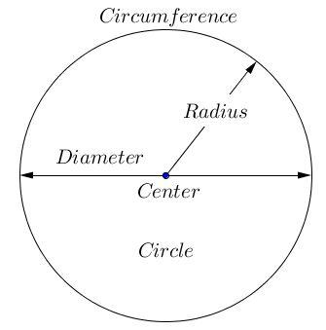
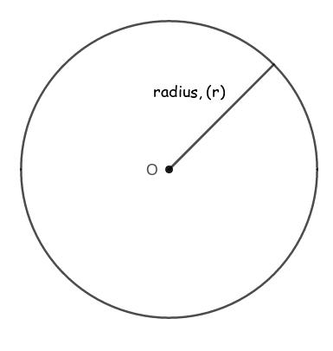
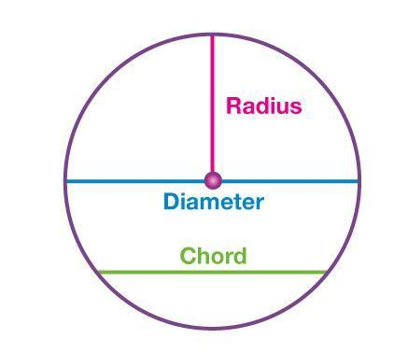
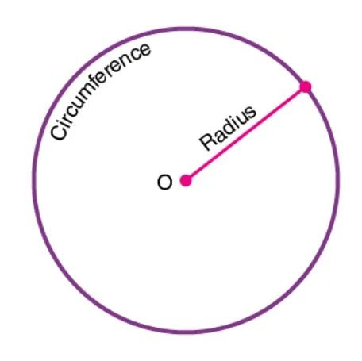
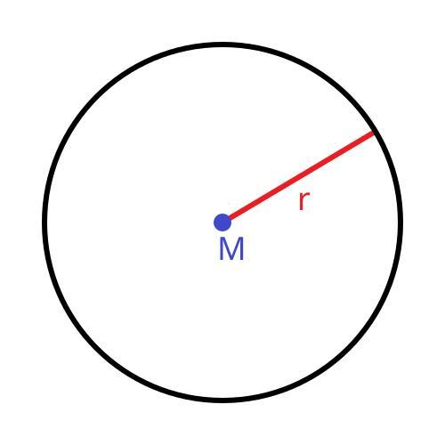
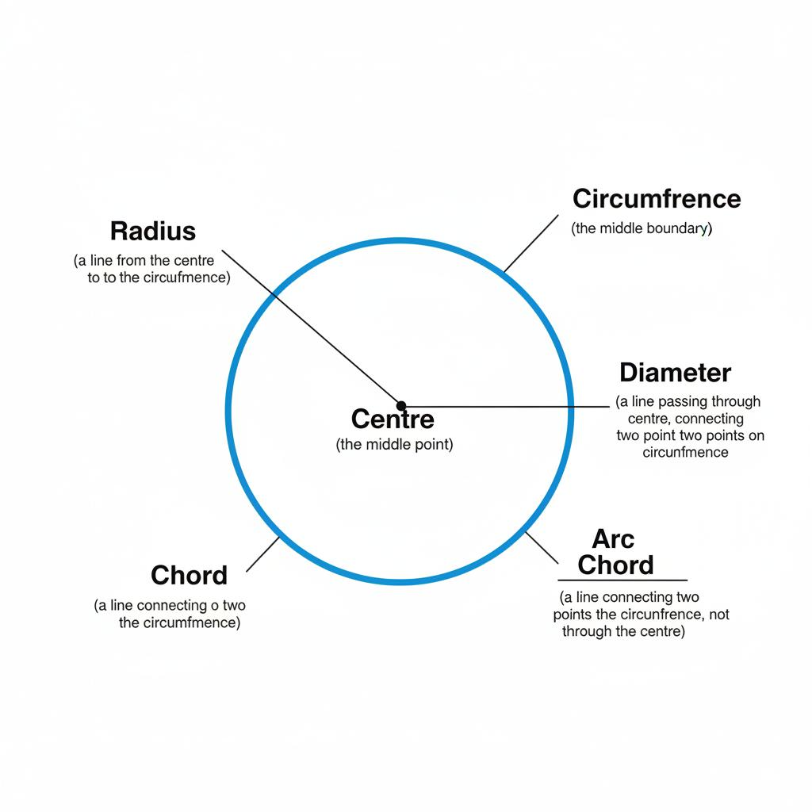

Definition
# Source: AI Source: Provided by: [Data Path: Persons Table -> ID Column: 1, Name_En Column: Motasem Essam] -> From: [ChatGPT] on [7/25/2026]
A radius is a line segment that connects the center of a circle to any point on its circumference.
The plural form is radii.
If $O$is the center of a circle and $A$is a point on the circle, then:
$$\overset{‾}{OA}$$
is a radius.

Fundamental Elements
# Source: AI Source: Provided by: [Data Path: Persons Table -> ID Column: 1, Name_En Column: Motasem Essam] -> From: [ChatGPT] on [7/25/2026]
- Center: $O$
- Endpoint at center: $O$
- Endpoint on circumference: $A$
- Radius: $\overset{‾}{OA}$
- Radius length: $r$
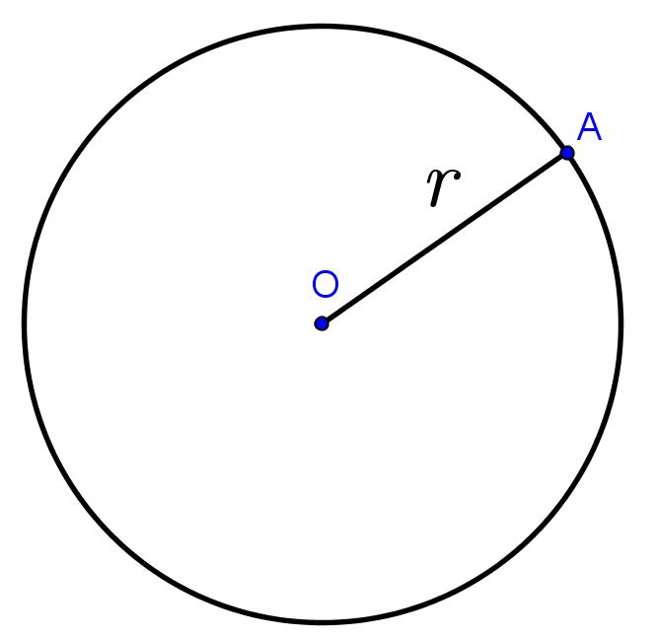
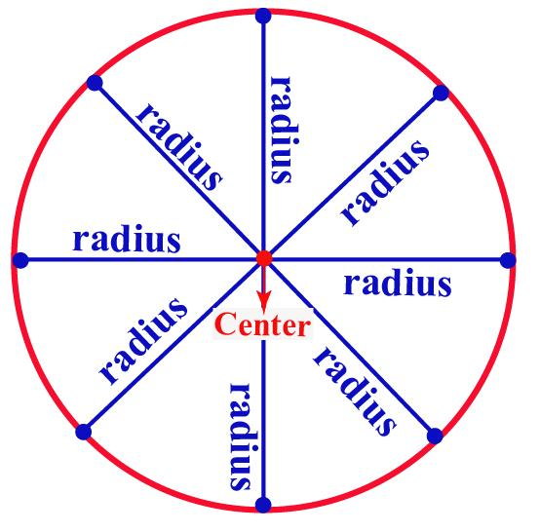
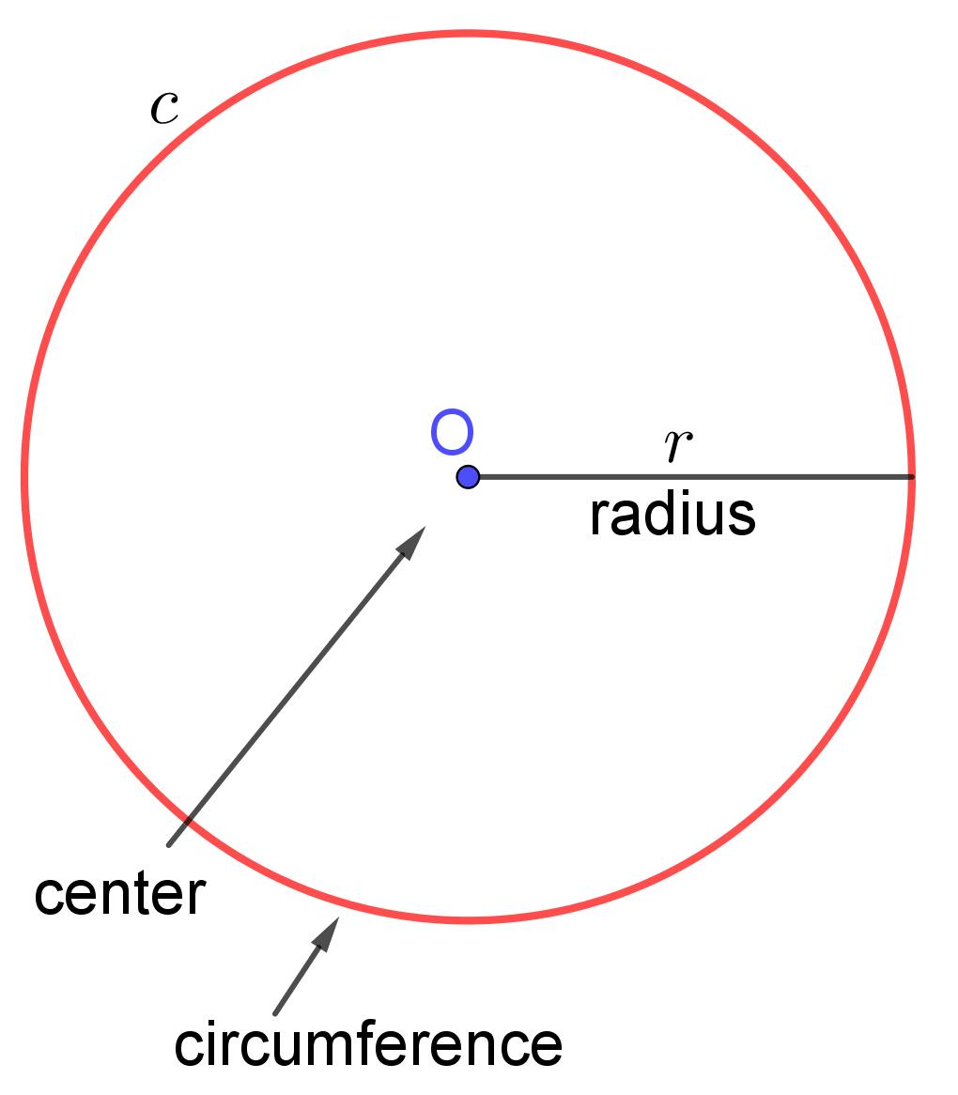
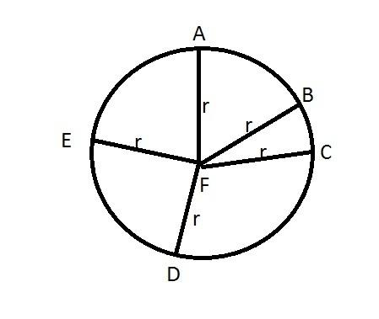

Main Properties
# Source: AI Source: Provided by: [Data Path: Persons Table -> ID Column: 1, Name_En Column: Motasem Essam] -> From: [ChatGPT] on [7/25/2026]
- Every radius of the same circle has the same length.
- A radius always starts at the center.
- A radius ends at a point on the circumference.
- A circle has infinitely many radii.
- The radius is half of the diameter.
$$d=2r$$
Therefore:
$$r=\frac{d}{2}$$

Radius and Diameter
# Source: AI Source: Provided by: [Data Path: Persons Table -> ID Column: 1, Name_En Column: Motasem Essam] -> From: [ChatGPT] on [7/25/2026]
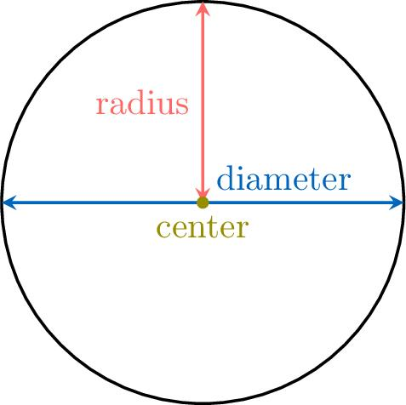
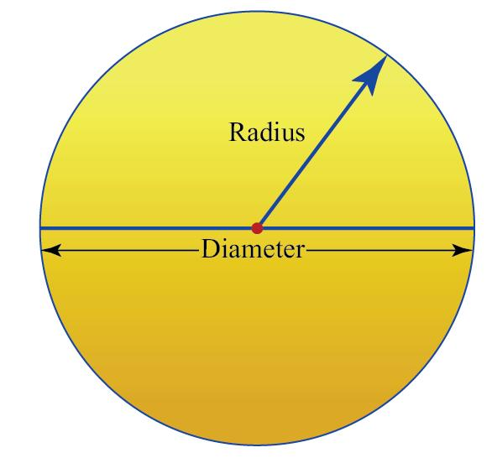
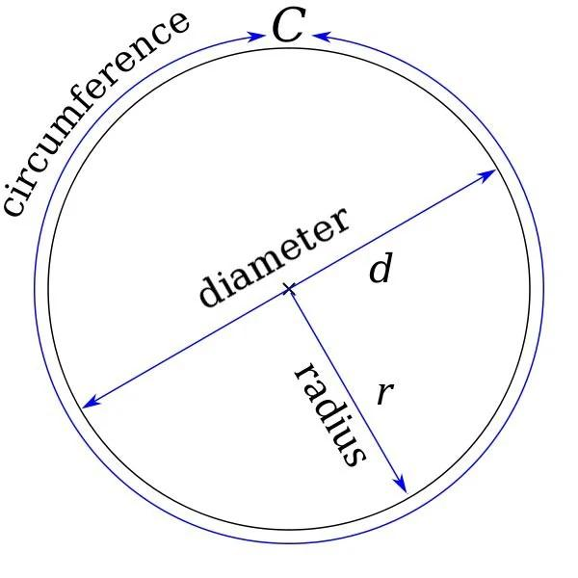
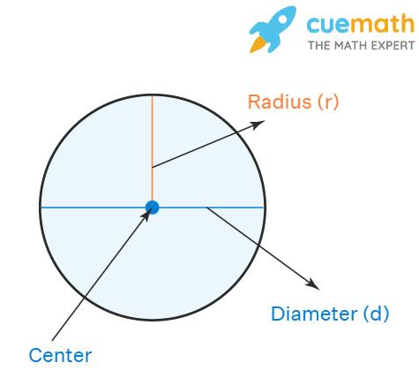
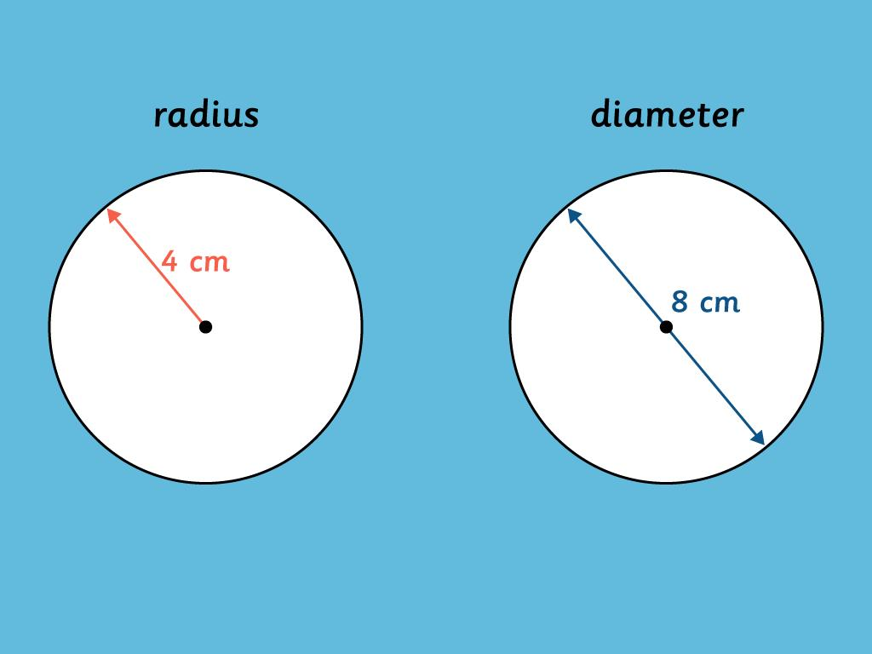
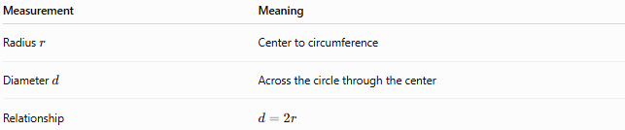
Measurement | Meaning
Radius $r$ | Center to circumference
Diameter $d$ | Across the circle through the center
Relationship | $$d=2r$$

Mathematical Applications
# Source: AI Source: Provided by: [Data Path: Persons Table -> ID Column: 1, Name_En Column: Motasem Essam] -> From: [ChatGPT] on [7/25/2026]
The radius is used in several fundamental circle formulas.
Circumference
$$C=2πr$$
Area
$$A=πr^{2}$$
Diameter
$$d=2r$$
Example
If a circle has radius $5\text{ cm}$:
$$d=2\left(5\right)=10\text{ cm}$$
and its area is:
$$A=π{\left(5\right)}^{2}=25π{\text{ cm}}^{2}$$

Related Concepts
# Source: AI Source: Provided by: [Data Path: Persons Table -> ID Column: 1, Name_En Column: Motasem Essam] -> From: [ChatGPT] on [7/25/2026]
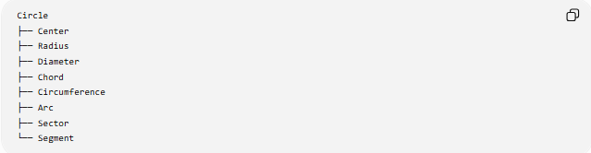
Circle
├── Center
├── Radius
├── Diameter
├── Chord
├── Circumference
├── Arc
├── Sector
└── Segment

Key Distinction
# Source: AI Source: Provided by: [Data Path: Persons Table -> ID Column: 1, Name_En Column: Motasem Essam] -> From: [ChatGPT] on [7/25/2026]
A radius is specifically a segment from the center to the circumference.
A diameter is a chord that passes through the center and consists of two radii placed end-to-end.

